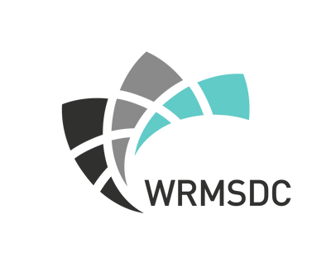

Evaluating a Working Group Checklist

№ | ACT IVIT IE S
1 | Review of Purpose and Goals  - Confirm that the group's purpose and goals are still relevant and aligned with the organization's objectives
2 | Membership Evaluation  - Assess whether the current membership composition adequately represents diverse perspectives and skills needed for the group's activities
3 | Roles and Responsibilities Review  - Review and update roles and responsibilities of members to ensure clarity and alignment with the group's objectives
4 | Communication Plan Check  - Evaluate the effectiveness of the current communication channels and protocols used by the group, as well as assess the responsiveness of members
5 | Resource Allocation  - Review resource allocation (financial, human, technological) to support the group's activities and ensure adequacy
6 | Meeting Effectiveness  - Evaluate the efficiency and effectiveness of group meetings, including frequency, agenda relevance, and engagement levels
7 | Documentation and Reporting  - Ensure that documentation of meetings, decisions, and action items is being maintained and shared appropriately
8 | Adherence to Protocols and Code of Conduct  - Ensure that the established protocols, code of conduct, and decision-making processes are being followed consistently
9 | Feedback and Improvement Mechanisms  - Establish or review feedback mechanisms to gather input from members and stakeholders for continuous improvement
10 | Succession Planning and Future Strategy  - Identify, develop, and prepare potential successors to ensure a smooth transition of leadership roles and members within the working group  - Discuss future plans, strategies, or initiatives that the group aims to undertake to achieve its long-term goals

